



Cisco Jabber Document

Created by: Shilpa Kaul | Version 1.0
Release Date: 10-18-21
INFRASTRUCTURE

Contents
Figures 3
Version History 4
Document Approver 5
Contributors 5
Overview 6
Audience 6
Install and Configure Cisco Jabber for Windows 7
Install and Configure Cisco Jabber for Mac OS 12
Cisco Jabber 12.8 Softphone Quick Start Guide 20
Jabber Phone Calls Using Microsoft Teams 21
Prerequisites 21
Installation Steps 21
Cisco Jabber/Teams Quick Start Guide 26

Figures
Figure 1: Search – Software Center 7
Figure 2: Software Center - Search 7
Figure 3: Install Cisco Jabber 8
Figure 4: Search for Jabber 8
Figure 5: Jabber – Associate login 9
Figure 6: Jabber – Agent login 10
Figure 7: Cisco Jabber window 11
Figure 8: Dock 12
Figure 9: Install Cisco Jabber 12
Figure 10: Confirm Installation 13
Figure 11: Install Cisco Jabber window 14
Figure 12: Install Cisco Jabber – License Agreement 14
Figure 13: Install Cisco Jabber – Select Destination 15
Figure 14: Cisco Jabber - Install 15
Figure 15: Cisco Jabber – Install Software 16
Figure 16: Install Cisco Jabber – Installation Complete 17
Figure 17: Applications folder – Cisco Jabber app 17
Figure 18: Jabber – Associate login 18
Figure 19: Jabber – Agent login 18
Figure 20: Cisco Jabber window 19
Figure 21: Apps icon 21
Figure 22: Search - Jabber 22
Figure 23: Microsoft Teams - Jabber 22
Figure 24: Microsoft Teams – Jabber - Add 23
Figure 25: Microsoft Teams – Cisco Jabber application 23
Figure 26: Open dial-in window 24
Figure 27: Dial-in window 24
Figure 28: Microsoft Teams – Jabber – Speed dial 25

Version History
Version | Date | Name | Comments/Changes
1.0 | 07-06-21 | Shilpa Kaul | Created initial draft of the document.
1.0 | 07-16-21 | Javier Mendez  David Rincon  Shilpa Kaul | Added the following sections with steps and procedure and screenshots:  - Install and Configure Cisco Jabber for Windows  - Install and Configure Cisco Jabber for Mac OS – Sign in, Log in  - Cisco Jabber Softphone Quick Start Guide  - Jabber Phone Calls using Microsoft Teams – Prerequisites, Installation Steps  - Cisco Jabber/Teams Quick Start Guide.
1.0 | 07-26-21 | Shilpa Kaul | Added figure captions to all the figures in the document.
1.0 | 08-04-21 | David Rincon  Shilpa Kaul | Incorporated Jesus’ review comments.  Added steps and screenshots to the following sections:  - Install and Configure Cisco Jabber for Windows  - Jabber Phone Calls Using Microsoft Teams
1.0 | 08-12-21 | Javier Mendez  David Rincon  Shilpa Kaul | Incorporated Jesus’ review comments.  Added steps and screenshots to the following sections:  - Install and Configure Cisco Jabber for Windows  - Install and Configure Cisco Jabber for Mac
1.0 | 08-24-21 | Jesus Sardinas | Reviewed the document. Rework required.
1.0 | 10-06-21 | Shilpa Kaul | Updated the section – Install and Configure Cisco Jabber for Mac OS
1.0 | 10-11-21 | Rodolfo Tejeda | Reviewed the document.
1.0 | 10-18-21 | Shilpa Kaul | Released the document.

Document Approver
Document Approver | Designation | Signature | Approval Date
 | Network/Telecom Engineering Manager, Technology Operations
 | Sr. Manager, Infrastructure Engineering, Technology Operations
 | Sr. Manager, Infrastructure Services, Technology Operations

Contributors
Contributor | Designation
 | Lead Telecommunications Engineer, Technology Operations
 | Senior Telecommunications Engineer, Technology Operations

Overview
This document is an overview of the Cisco Jabber soft phone installation and configuration along with the Microsoft Teams plug-in integration.

Audience
The intended audience of this document are the Lennar Technology Solutions (LTS) personnel.

Install and Configure Cisco Jabber for Windows
This section will guide you on the process of installation and configuration of Cisco Jabber for Windows.
- Go to the search bar on the bottom left corner of your desktop and search for ‘Software Center’.
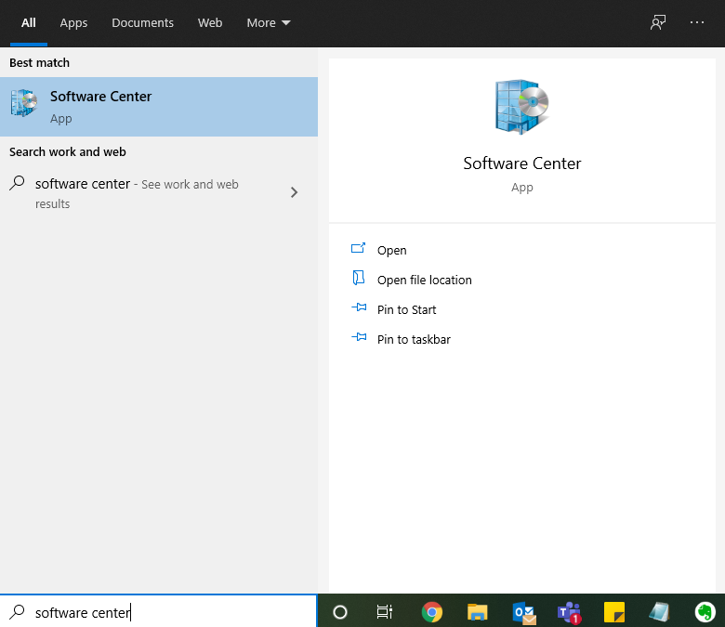
Figure 1: Search – Software Center
Note: You need to be on the corporate network. If you are working remotely make sure your VPN (Global Protect) is connected. Click here for more information on Global Protect.
- In Software Center, search for Jabber.
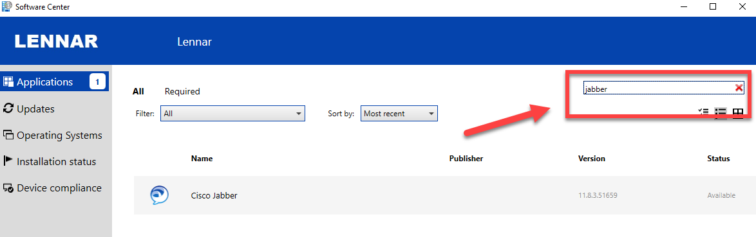
Figure 2: Software Center - Search
- Click Jabber and click Install.
Note: Software center downloads and starts the installation process. Depending on your internet speed, installation time may vary.
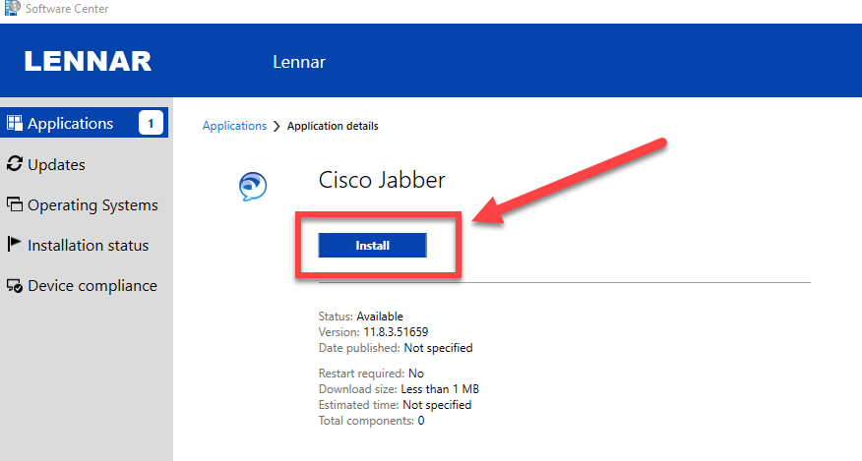
Figure 3: Install Cisco Jabber
- The Cisco Jabber window will be displayed a few moments later.
- In case the Jabber window is not displayed automatically, search for the Jabber software.
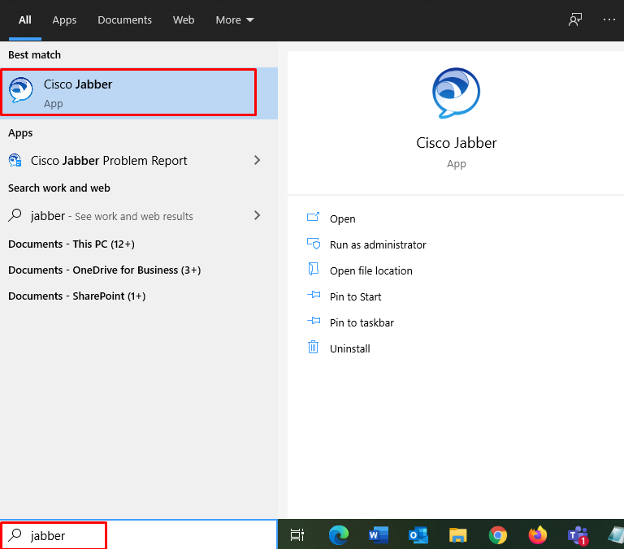
Figure 4: Search for Jabber
- For Associate login, enter ‘first.lastname@lennar.com’ in the empty field and click the Continue button.
Example: javier.mendez@lennar.com.
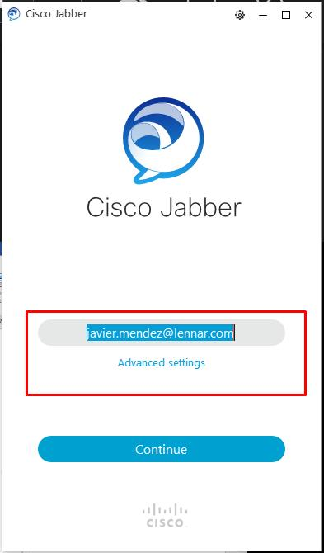
Figure 5: Jabber – Associate login
- Enter your password in the field below and click Sign In.
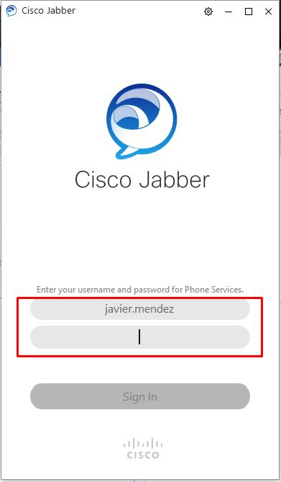

- For call center Agents to login, enter ‘phonenumber@lennar.com’ in the empty field and click the Continue button.
Example: 5556666032@lennar.com.
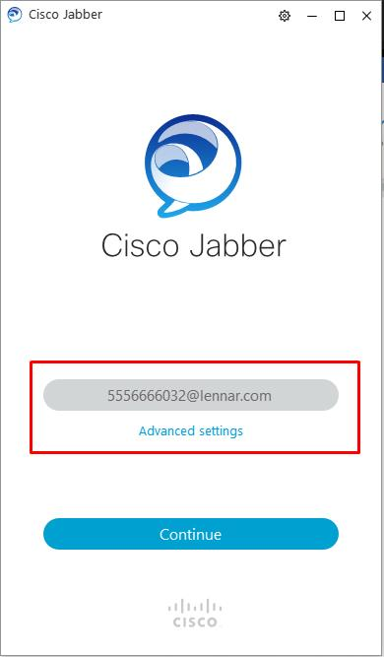
Figure 6: Jabber – Agent login
- Enter your password in the field below and click Sign In.
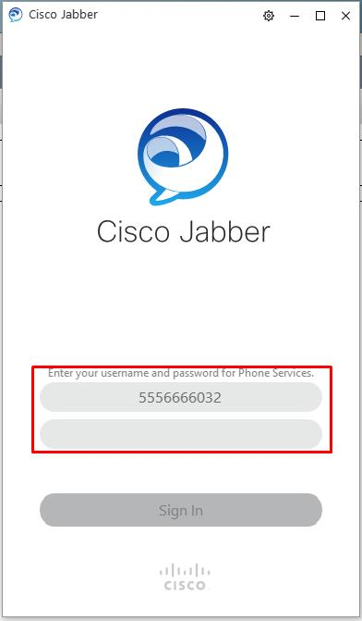

- You are now ready to use Cisco Jabber.
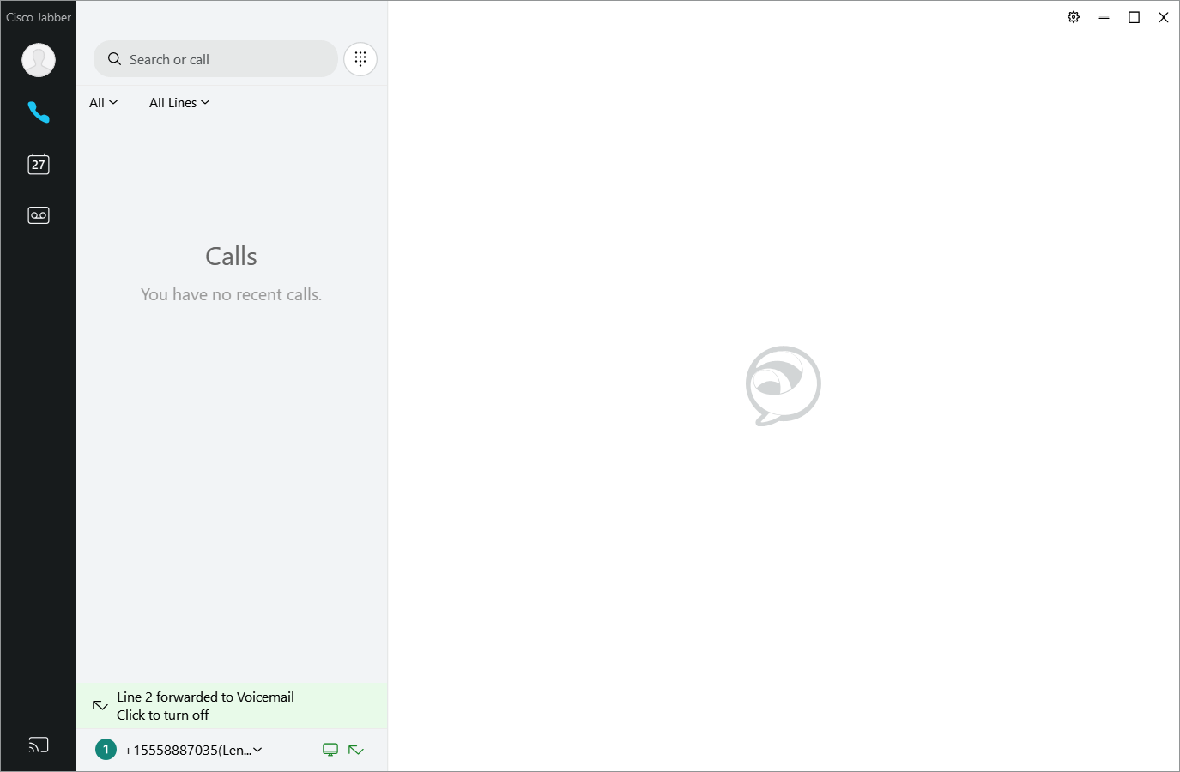
Figure 7: Cisco Jabber window

Install and Configure Cisco Jabber for Mac OS
Download Cisco Jabber for Mac from the Lennar Apps Portal.
- Open the Lennar Portal App found on the Dock.

Figure 8: Dock

- Click Install next to Cisco Jabber.
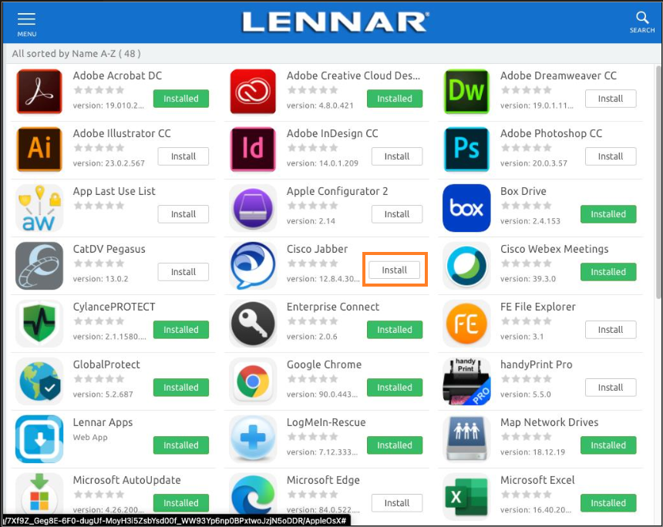
Figure 9: Install Cisco Jabber

- A pop-up window is displayed. Click Install.
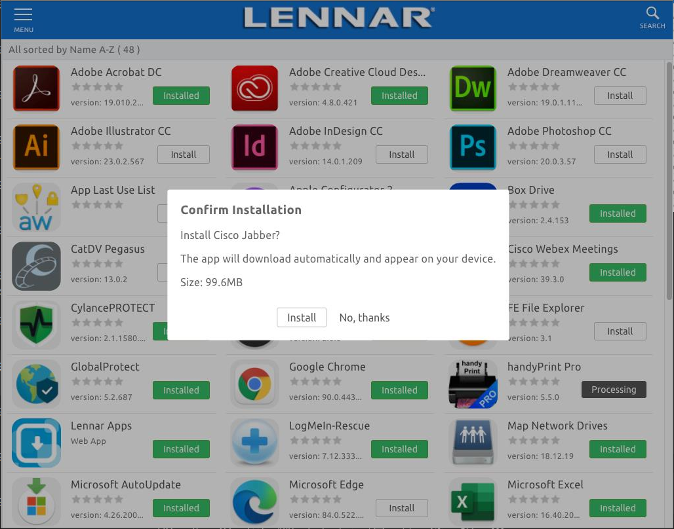
Figure 10: Confirm Installation
- After a few minutes the application will appear in the Applications folder.
- Double click the Cisco Jabber installation file.

- The Welcome screen is displayed, click Continue.
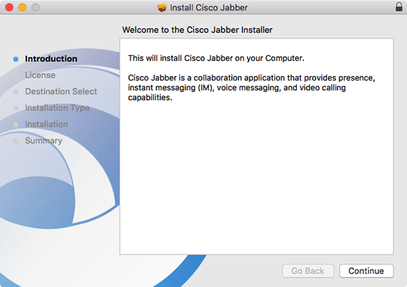
Figure 11: Install Cisco Jabber window
- Read the license agreement if you wish and then click Continue. Click Agree to accept the terms of the license agreement and continue with the installation.
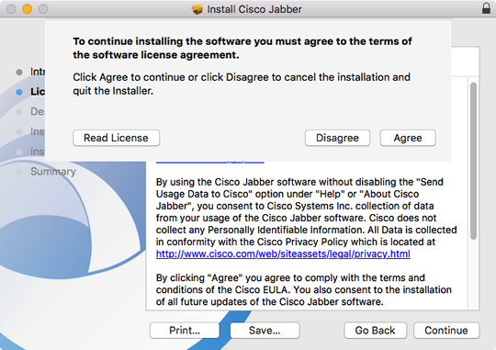
Figure 12: Install Cisco Jabber – License Agreement
- You will be prompted to select the disk where you want to install Jabber. Select your hard drive and then click Continue.
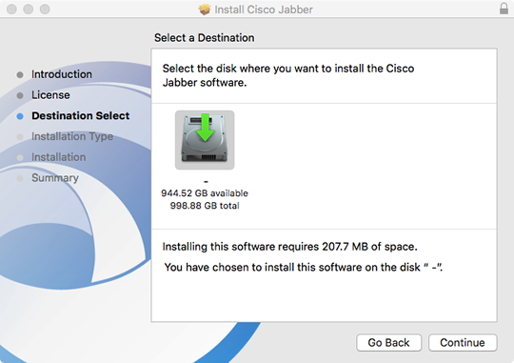
Figure 13: Install Cisco Jabber – Select Destination
- Click Install to perform the standard installation.
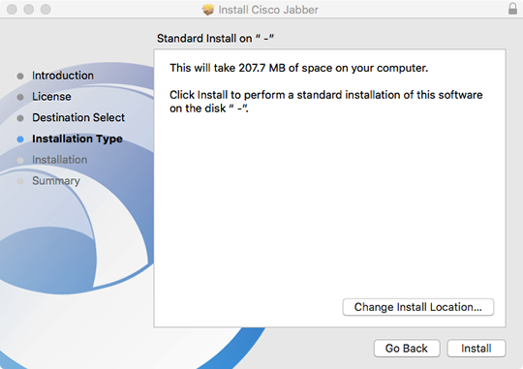
Figure 14: Cisco Jabber - Install
- At the prompt, enter your administrator account password for the Mac and click Install Software.
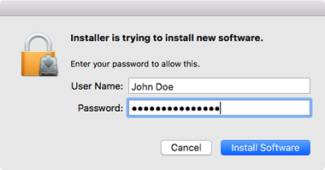
Figure 15: Cisco Jabber – Install Software

- When the software has finished installing, click Close.
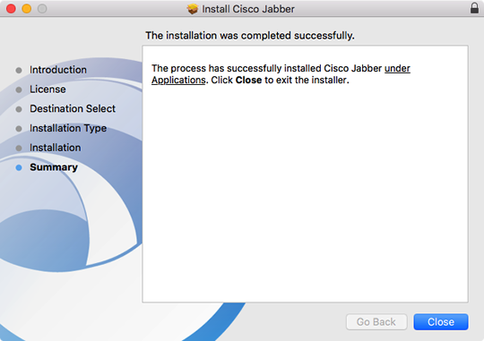
Figure 16: Install Cisco Jabber – Installation Complete
- To launch Jabber, open your Applications folder and double-click the Cisco Jabber.app icon.
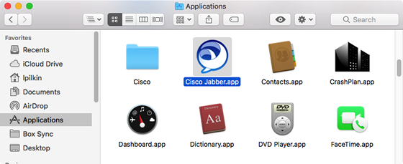
Figure 17: Applications folder – Cisco Jabber app

- For Associate login, enter ‘first.lastname@lennar.com’ in the field and click the Continue button.
Example: javier.mendez@lennar.com.

Figure 18: Jabber – Associate login
- Enter your password in the field below and click Sign In.
- For call center Agents to login, enter ‘phonenumber@lennar.com’ in the field and click the Continue button.
Example: 5556666032@lennar.com.

Figure 19: Jabber – Agent login
- Enter your password in the field below and click Sign In.

- You are now ready to use Cisco Jabber.

Figure 20: Cisco Jabber window

Cisco Jabber 12.8 Softphone Quick Start Guide
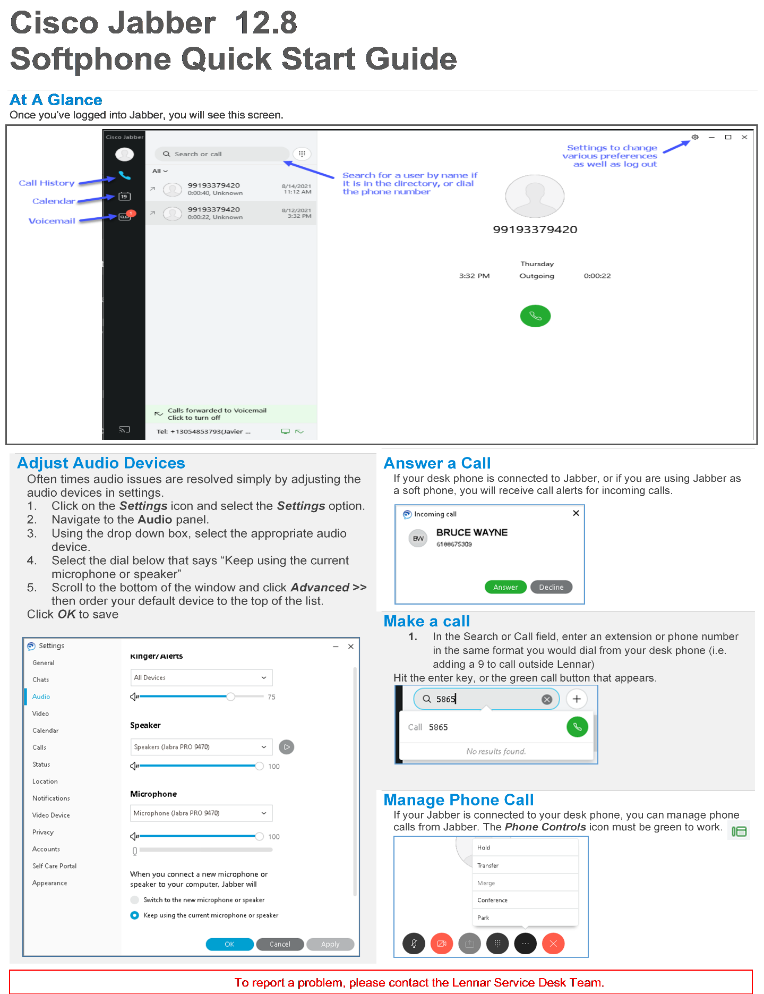

Jabber Phone Calls Using Microsoft Teams
This section explains how to install the Jabber application inside Microsoft Teams and use it to make phone calls.

Prerequisites
Following are the prerequisites:
- Microsoft Teams installed on your PC/Mac.
- Cisco Jabber installed on your PC/Mac.

Installation Steps
Once the prerequisites are met, follow the steps outlined below:
- Launch Cisco Jabber.
- Launch Microsoft Teams and click the Apps icon on the bottom left of the Microsoft Teams window.
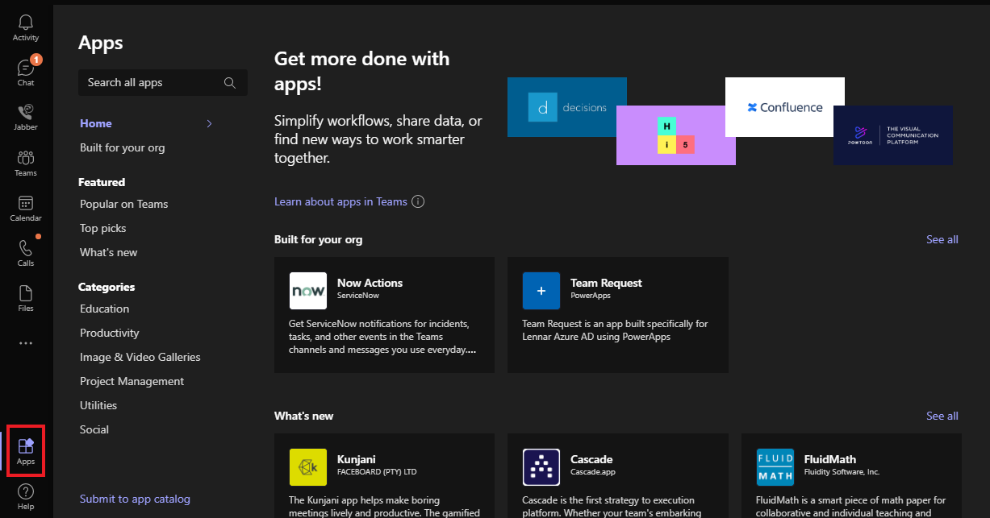
Figure 21: Apps icon
- Use the search bar labeled Search all apps to find Jabber. It will be displayed as the first search result.
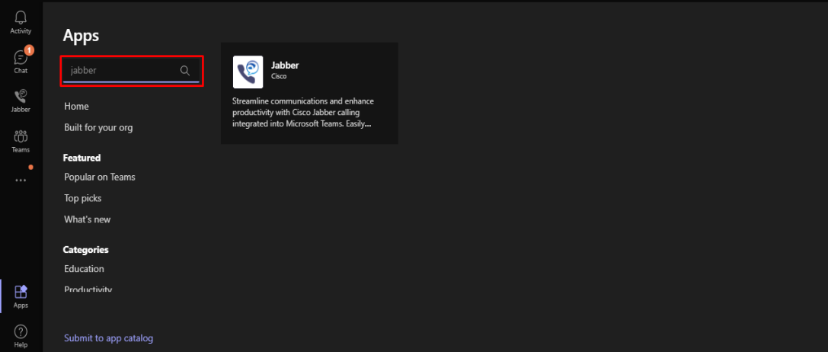
Figure 22: Search - Jabber
- Click the Jabber tile.
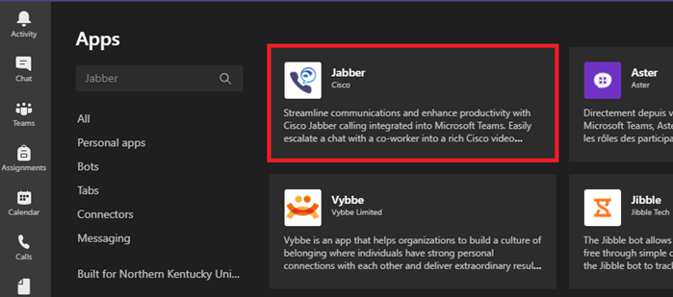
Figure 23: Microsoft Teams - Jabber

- Click the Add button on the next page.
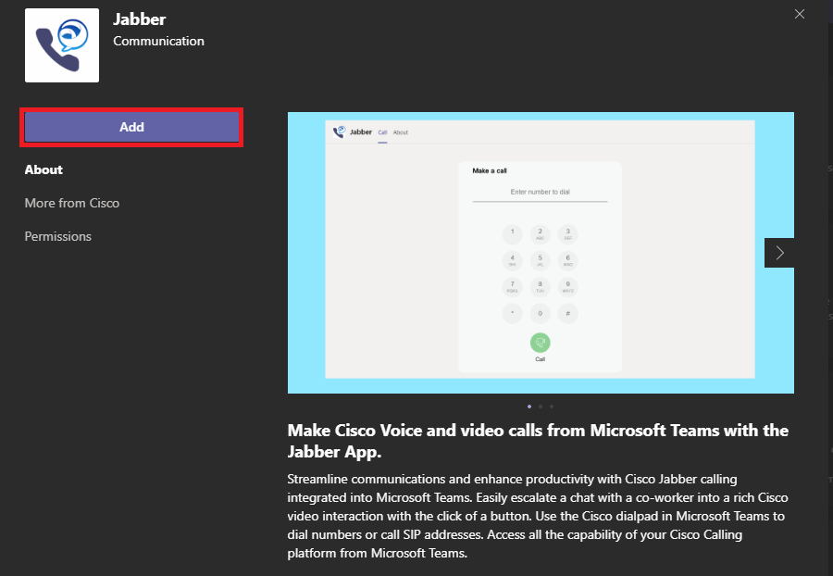
Figure 24: Microsoft Teams – Jabber - Add
- After the Jabber extension is installed, you will be directed to the Cisco Jabber application in Microsoft Teams.
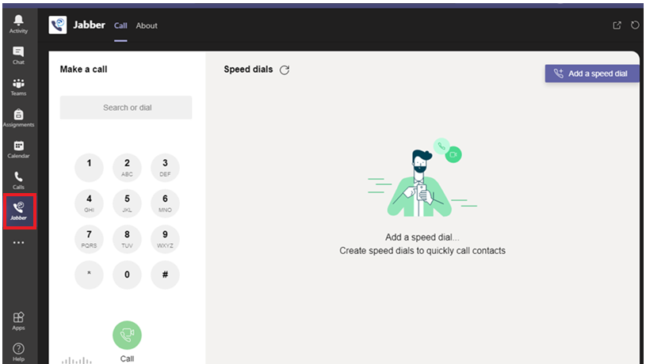
Figure 25: Microsoft Teams – Cisco Jabber application

- Jabber is now ready for use.

- To initiate a phone call, click the dots (as shown in the figure) to open the dial-in window.
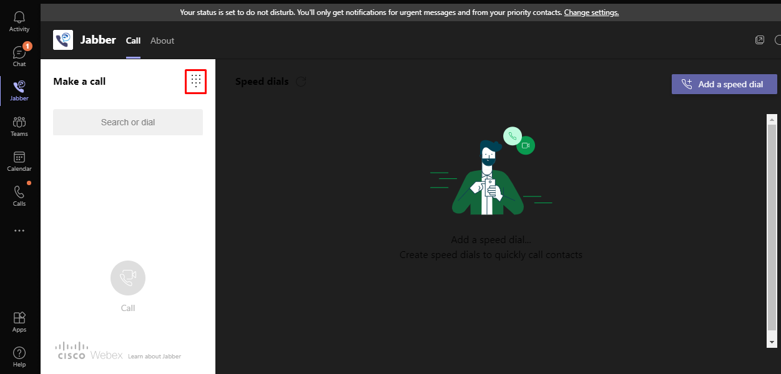
Figure 26: Open dial-in window

- The following dial-in window is displayed. To make a phone call, you must dial 9 followed by the 10-digit phone number. Press the green call button to initiate your phone call.
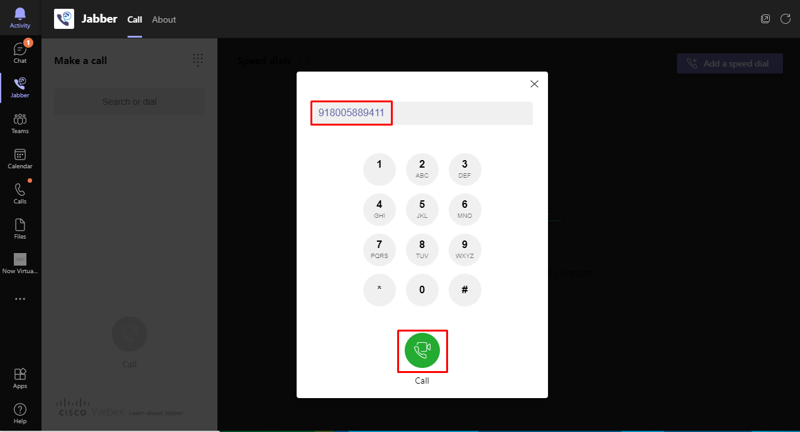
Figure 27: Dial-in window
- The call will be launched using the Cisco Jabber application.
Note: You can quickly call contacts by using the Add a speed dial button.
Note: You can also call people directly from a chat conversation by clicking the Jabber icon within the chat window.
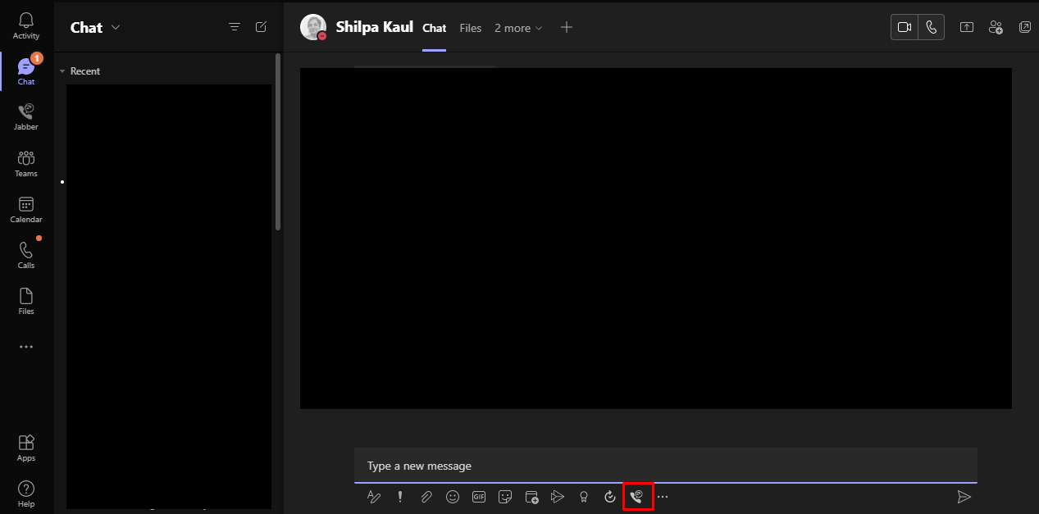
Figure 28: Microsoft Teams – Jabber – Speed dial

Cisco Jabber/Teams Quick Start Guide

